Project Design Phase-II

Data Flow Diagram & User Stories

|  |  |
| --- | --- |
| Date | 09 November 2022 |
| Team ID | PNT2022TMID50435 |
| Project Name | Smart fashion recommeneder |
| Maximum Marks | 4 Marks |

# Data Flow Diagrams:

A Data Flow Diagram (DFD) is a traditional visual representation of the information flows within a system. A neat and clear DFD can depict the right amount of the system requirement graphically. It shows how data enters and leaves the system, what changes the information, and where data is stored.

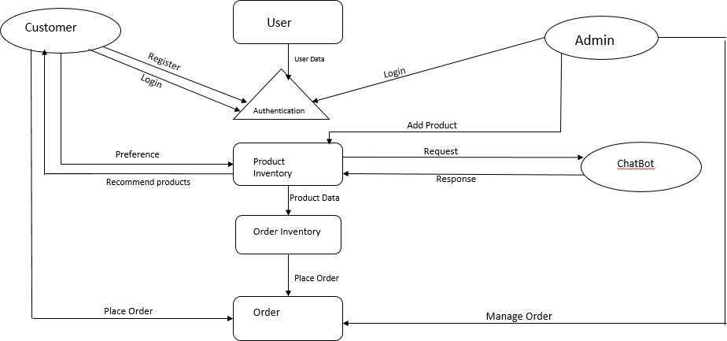

# User Stories

Use the below template to list all the user stories for the product.

|  |  |  |  |  |  |  |
| --- | --- | --- | --- | --- | --- | --- |
| **User Type** | **Functional**  **Requirement (Epic)** | **User Story Number** | **User Story / Task** | **Acceptance criteria** | **Priority** | **Release** |
| Customer (Mobile user) | Registration | USN-1 | As a user, I can register for the application by entering my email, password, and confirming my password. | I can access my account / dashboard | High | Sprint-1 |
|  |  | USN-2 | As a user, I will receive confirmation email once I have registered for the application | I can receive confirmation email & click confirm | High | Sprint-1 |
|  |  | USN-3 | As a user, I can register for the application through Facebook | I can register & access the dashboard with Facebook  Login | Low | Sprint-2 |
|  |  | USN-4 | As a user, I can register for the application through Gmail |  | Medium | Sprint-1 |
|  | Login | USN-5 | As a user, I can log into the application by entering email & password | I can access and place my order. | High | Sprint-1 |
|  | Dashboard |  |  |  |  |  |
| Customer (Web user) | Registration | USN-1 | As a user , I can sign up for the application as by putting in my password, email, and confirming. | I can access my account . | High |  |
|  |  | USN-2 | As a user, an email confirmation will be sent to me once I've submitted my information. | I can get a confirmation email and confirm it. | High |  |
|  |  | USN-3 | As a user, I can register for the application through Google. | I can register & access the  dashboard with Google Login. | High |  |
|  |  | USN-4 | As a user, I can’t log into the application by  entering email & password. | I can’t access my account  after I registered. | Low |  |
| Customer Care Executive |  | USN-1 | As a customer executive, I can fix the application's login problem and other problems. | I am available 24/7 to offer support or alternative solutions. | Medium |  |
| Administrator |  | USN-1 | As an administrator, I can update or enhance the application. | I can authorise transactions and products. | Medium |  |